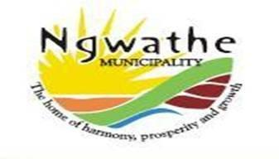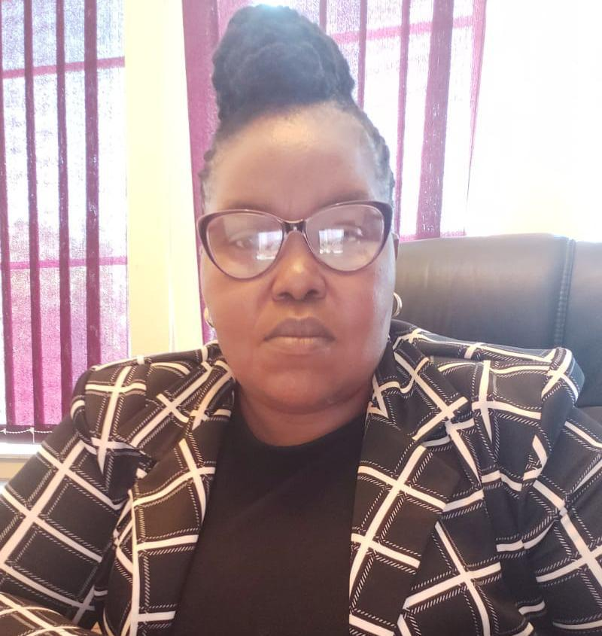
To Community members of Office of the Speaker
Ngwathe Municipality. P.O. Box 359
PARYS

The Speaker of Ngwathe Local Municipality Cllr: NP Mopedi hereby invites the community members to the Ordinary Meeting of Ngwathe Local Council which will be held as follows:

12 NOVEMBER 2024
AT 10:00

Parys Forum Building

CLLR NP MOPEDI
CHAIRPERSON
31 October 2024

